IP Notes:

Terminal Commands:

Cd – Current directory (cd ~)

Pwd: Print Working directory

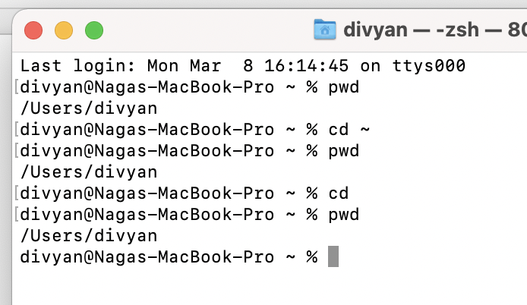

Ls – List of files In pwd.

to go into particular directory: cd dirname/

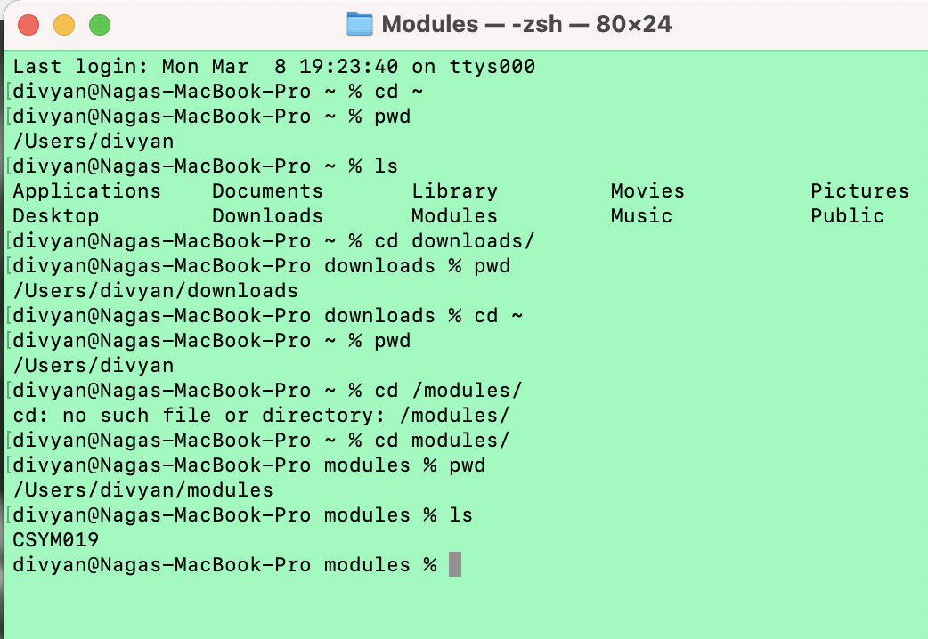

Cd downloads/ or cd Downloads/ -> Same

Cd /downloads/ -> This is error

*To Go back to previous directory: -> Cd .. // Goes to previous

*If present in sub and want to go to other sub: -> cd ../Week-2/

CSS Selectors:

* # -> to get id of HTML element.
* . -> To access class of particular HTML elements.
* Li span -> span inside in the <li>
* Li.special -> <li> elements which had class=”special”
* H1 + p -> Immediate <p> after <h1>.
* /* selects any <span> that is inside a <p>, which is inside an <article> */
* article p span { ... }
* /* selects any <p> that comes directly after a <ul>, which comes directly after an <h1> */
* h1 + ul + p { ... }

CSS Structure:

1. External Stylesheet
2. Inline styles
3. Internal Stylesheet

External Stylesheet:

Adding external resources (.css) to the file and using by <link>.

<!-- Inside a subdirectory called styles inside the current directory -->

<link rel="stylesheet" href="styles/style.css">

<!-- Inside a subdirectory called general, which is in a subdirectory called styles, inside the current directory -->

<link rel="stylesheet" href="styles/general/style.css">

<!-- Go up one directory level, then inside a subdirectory called styles -->

<link rel="stylesheet" href="../styles/style.css">

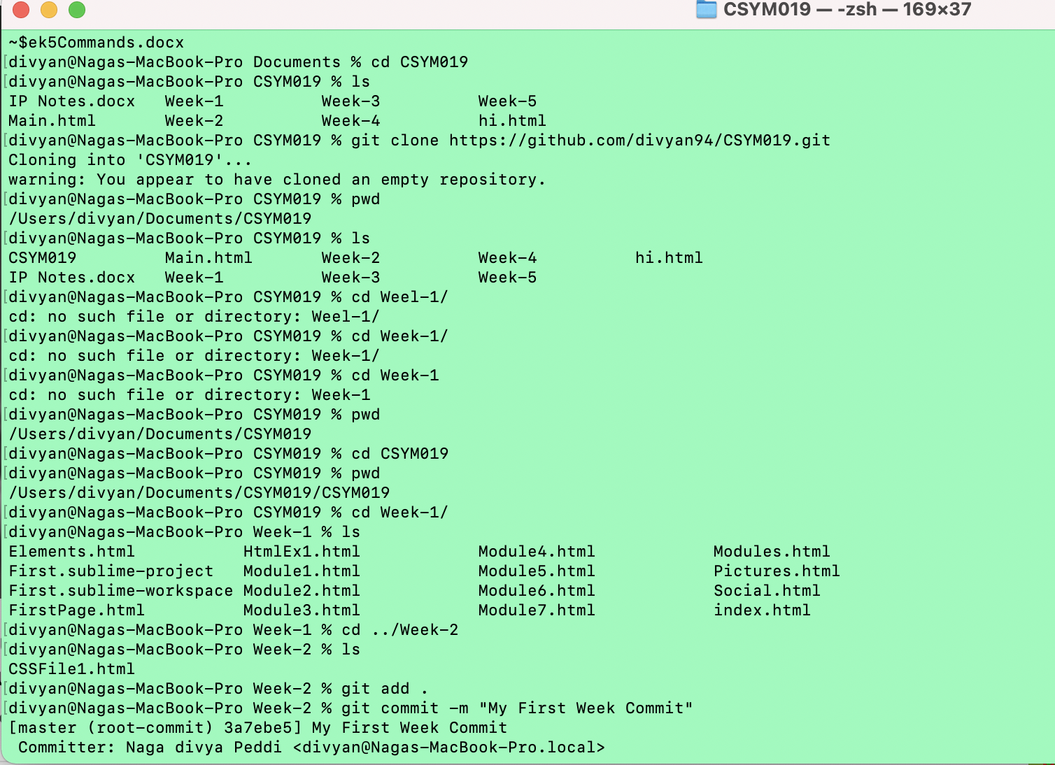

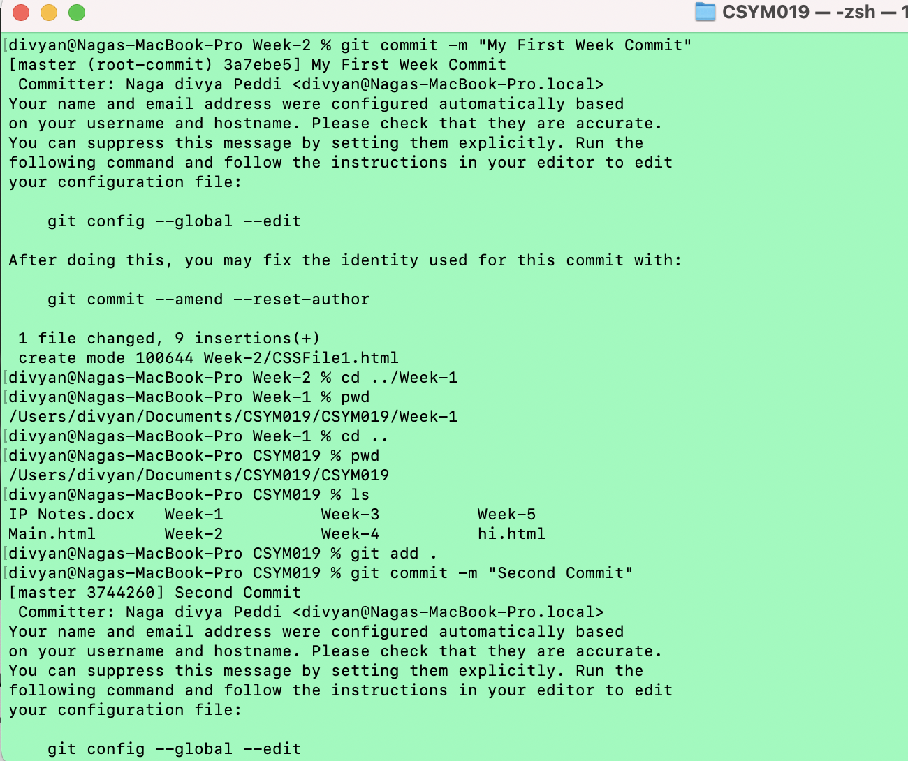

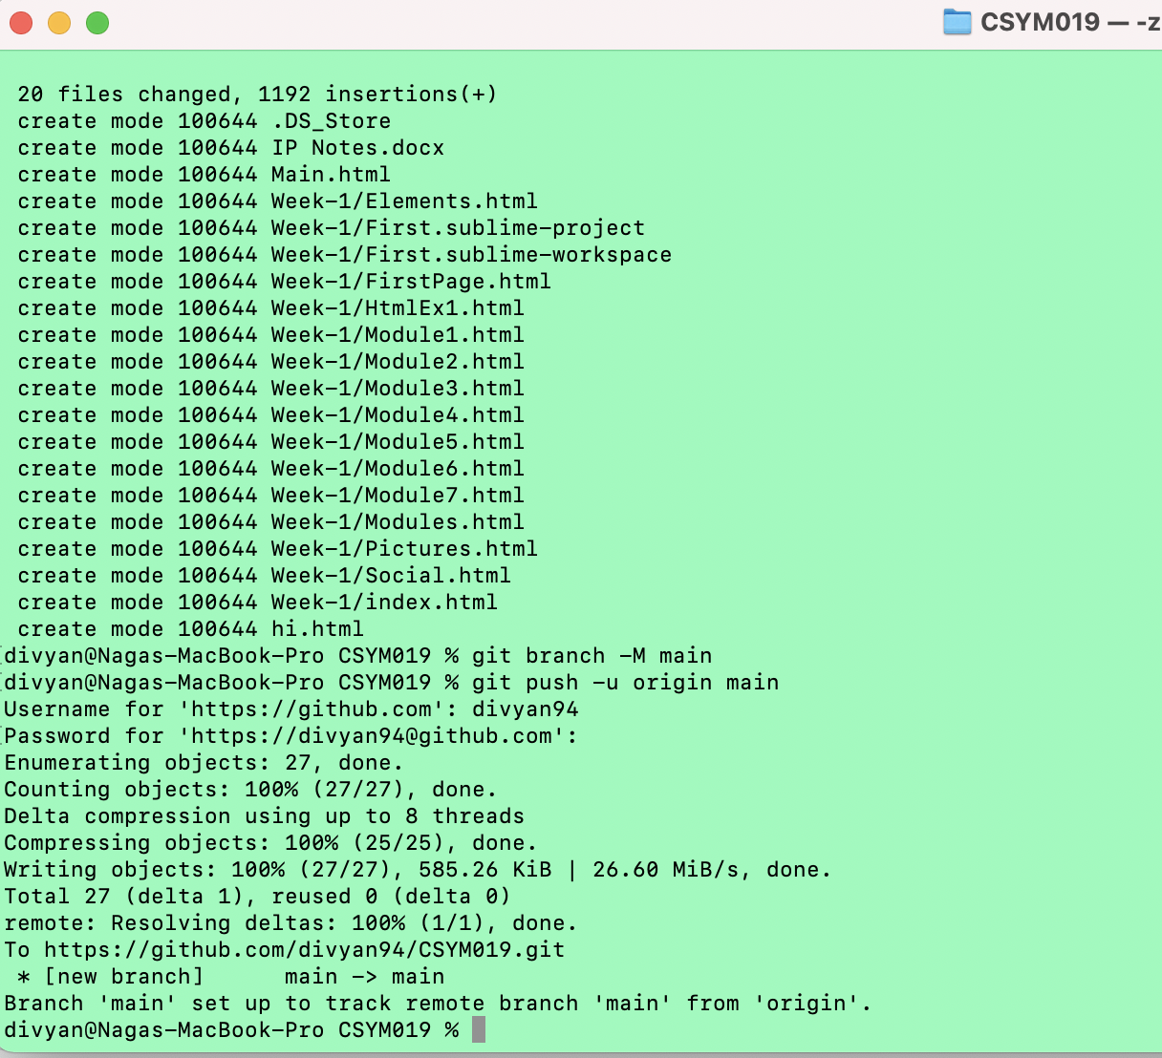

Json:

It stores data and send and receive between the applications.

Json object stores in the variable.

Arrays – List of values

Ex:

p.name;

p.child.name;

p.child[1].name;

p[2].name;

p.child[2].dob;

p.child[2].dob

orders[256].items[4].product.manufacturer.address.postcode

Objects

Arrays

Multiple arrays and objects

Can create object in an array

Can create array in object

var myBTS = [

{

"name": "Kim Namjoon",

"dob" : 1994

},

{

"name": "Kim Seokjin",

"dob" : 1992

},

{

"name": "Min Yoongi",

"dob" : 1993

},

];

alert(myBTS[0].dob);

alert(myBTS[2].name + " " + " born in " + " " + myBTS[2].dob);

var bts2 = {

"name" : "BTS",

"concertLocations" : [

{

"locationName" : "Chicago",

"year" : 2017

},

{

"locationName" : "Wembley",

"year" : 2018

},

{

"locationName" : "Japan",

"year" : 2016

}

]

};

Json:

Primitive datatypes and Collections

Such as string, number, Boolean and null values

Objects and arrays can also be the values

Some data typesis not included in json such as map,regular expressions, functions and undefined

Json Schema:

Overall json data design

It allows the specific datatypes and restrictions on data values

Json schema files are written in Json only

Json Validation:

Json data and json schema files both should check against each other so that we know the data is invalid or valid.

Declaration of schema:

Include ‘$schema’ as keyword in the file to declare as it is schema

{

“$schema” : “link”

}

Schema Meta-data:

Should include:

Title and description key/value pairs:

{

“$schema”: “link”,

“title” : “Weather Report”,

“Description” : “Checking the weather conditions of uk”

}

Structuring Data:

We need to include type, properties and array items, data items:

Data types: which data type of the json object,

Object properties: which Element’s properties(attributes) should be present for the object,

Array items: Which elements need to be in an array.

“type” : “object”,

“properties” : { “type” : “array” ,

“items” : { “id” : { “type” :“string”}, ”title” :{“type” : “string”}, “desc” : {“type” : “string”},   
 isAvailable: {“type” : “Boolean”}, “year” : {“type”: “number”}, “album” : {“type” : “array”, “items” : {“type” : “object”,”properties” : { “title” : {“type” : “string”}, “year” : {“type” : “number” },

}

}

}

}

**Json schema restrictions:**

We can give restrictions on Json Properties or items as follows:

String: maxLength, minLength, enum, default, pattern

Number: maxLength, minLength, number, pattern, default

Boolean: default,

Object: maxProperties, minProperties

Array: minItems, maxItems

Example of Json schema restrictions:

{

Properties: {

“position” : {“type” : “string”, “enum” : [“Singer”,”Rapper”,”dancer”, “Visual”,”Leader”]}, “dob” : {“type” : “number” , minLength:4, maxLength:4,

“isAvailable”: {“type” : “boolean” , “default”: true},

“birthplace” : {“type” : “String”,required}

Json Exercise: Week-7

Have tried three samples of date.

{

"sightings": [

{

"id" : 1,

"animal" : "Pine Martin",

"number" : 4,

"location" : "Marshall Woods, Reneham",

"date" : "2015-09-24",

"time" : "09:30:00",

"observer" : {"name" : "divya",

"email" : "divya@gmail.com"

},

"observations" : "Four Pine Martins. 1 adult 3 juveniles. In Wooded area, Adult appeared to be mother."

},

{

"id" : 2,

"animal" : "Otter",

"number" : 7,

"location" : "Vijayawada, Andhra Pradesh",

"date" : "2016-0-20",

"time" : "10:12:00",

"observer" : {

"name" : "Swathi",

"email" : "swathi@gmail.com"

},

"observations" : "Seven Otter found. All are cute babies."

},

{

"id" : 3,

"animal" : "Beaver",

"number" : 5,

"location" : "California",

"date" : "2015-08-24",

"time" : "20:30:00",

"observer" : {

"name" : " Borris Johnson",

"email" : "Borris@gmail.com"},

"observations" : "Five Beaver Found"

}

]

}

And validate for well formedness through jsonlint.com

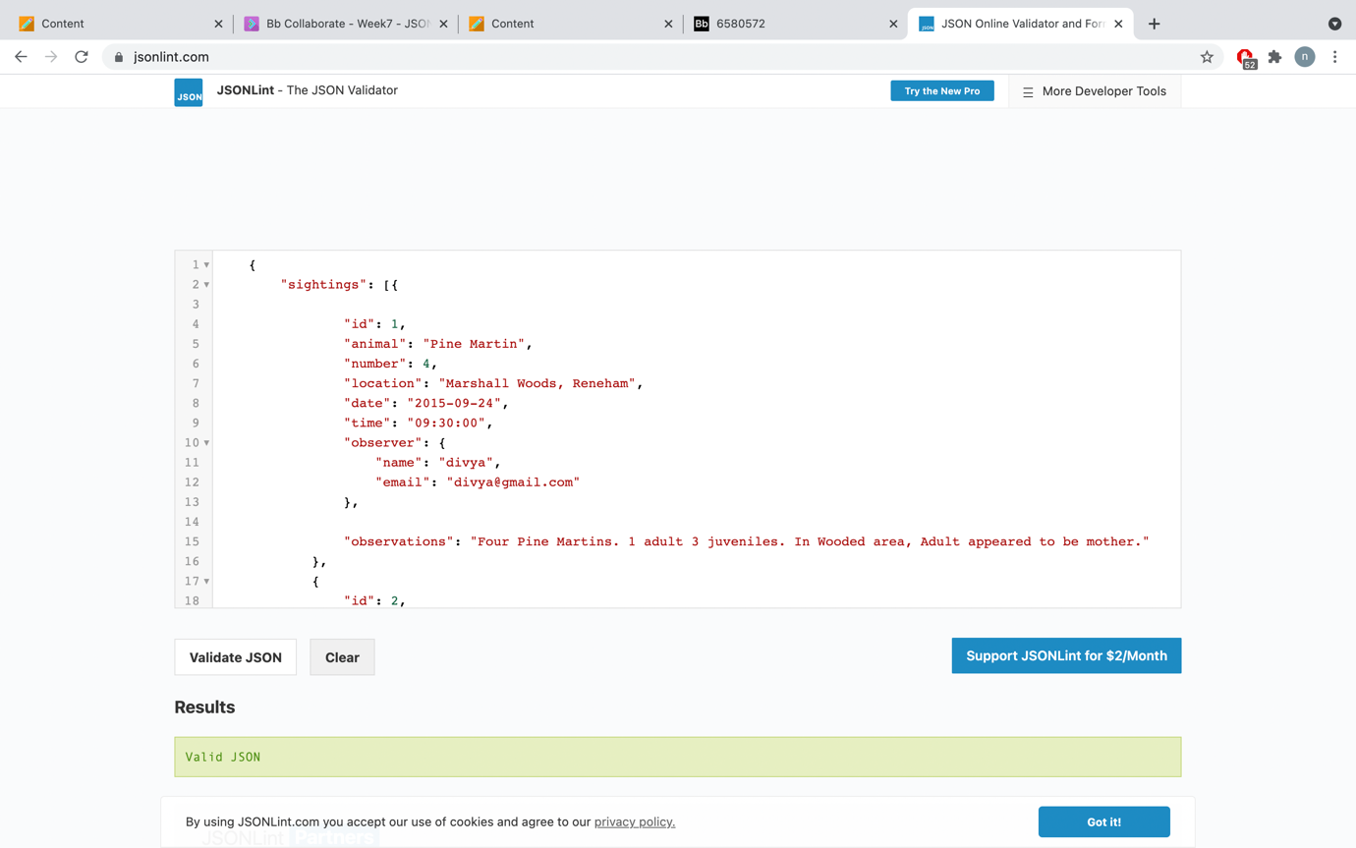

**Creating Json Schema:**

1. First create a file ‘sightingschema.json’
2. Declare schema, title and description as below as example
   1. {
   2. "$schema" : "http://json-schema.org/draft-04/schema#",
   3. "title" : "UK Weather report",
   4. "description" : "Report of Weather in England "
   5. }

Then add whole schema as below:

{

"$schema" : "http://json-schema.org/draft-04/schema#",

"title" : "Sightings Report",

"description" : "Reports of rare animal Sightings in Exland",

"type" :"object",

"properties" : {

"sightings" : {

"type" : "array",

"items" : {

"type" : "object",

"properties" : {

"id" : {"type":"integer"},

"animal" : {"type" : "string"},

"number" : {"type" :"integer"},

"location" : {"type" :"string"},

"date" : {"type" :"string"},

"time" :{"type" : "string"},

"observer" :{ "type" : "object",

"properties" : {

"name" : {" type" : "string"},

"email" : {" type" : "string"}

},

"observations" : {"type" : "String"}

}

}

}

}

}

}

Then validate against the schema in jsonschemavalidator.net

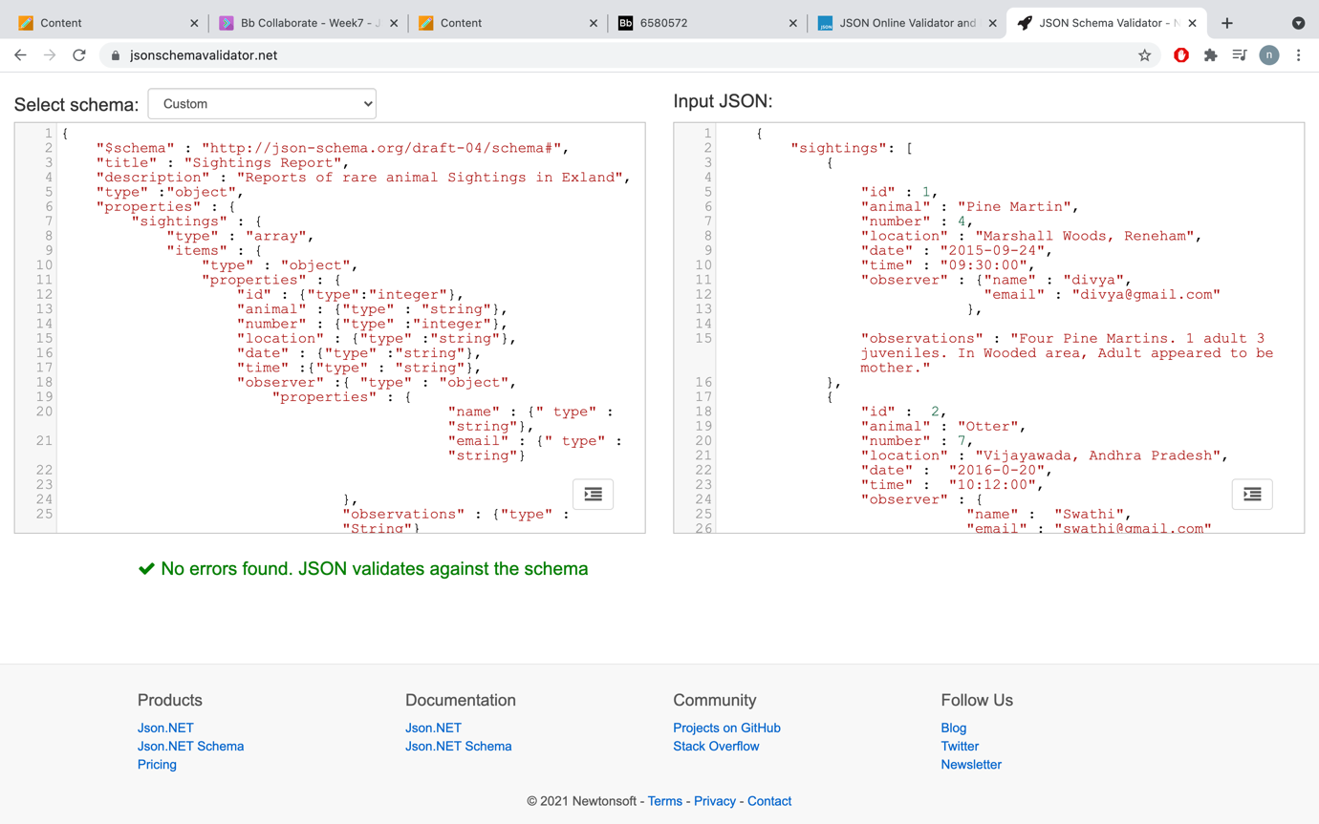

The above data can be saved as below url

<https://www.jsonschemavalidator.net/s/yuRvOsBg>

Add Restrictions:

1. Add enum to animal names and add four values like below

"animal" : {"type" : "string","enum" : ["Pine Martin", "Otter","Beaver", "Hare"]},

Then try to validate:

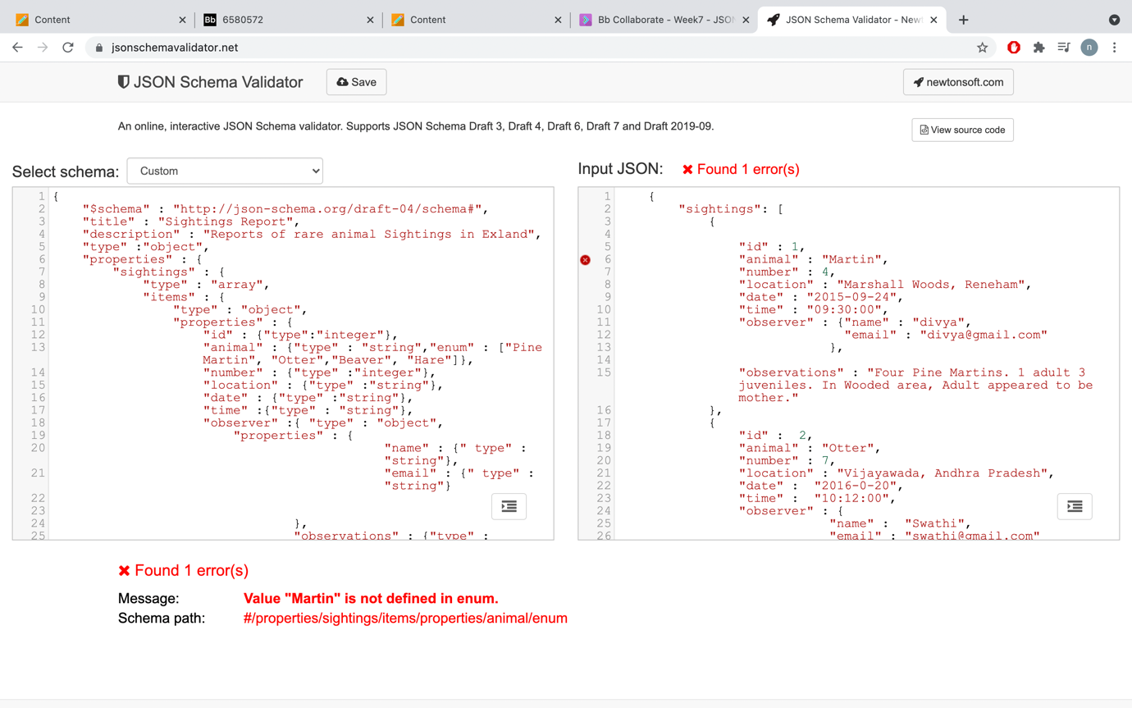

**Week – 8:**

Ajax: Asynchronous Javascript and XML.

To create web applications for front end side ( client side) more responsive and update dynamically which means partially update the page without any interaction with other html elements.

Ajax make use of javascript to update this work.

a)Traditional Requests to server Is using ‘HTTP Requests’

b) Ajax Requests to server is using ‘XHR’ – ‘XMLHTTPRequest’ object.

c) ajax works with json, text file , csv, html also

How it works:

1. A user initiated event occurs (e.g. form submit).

2. An XMLHttpRequest object is created.

3. The XMLHttpRequest object is configured.

4. The XMLHttpRequest object makes an asynchronous request to the web server.

5. The web server returns the response data (or an error).

6. A JavaScript callback function is used to process the response data.

7. The HTML DOM is updated.

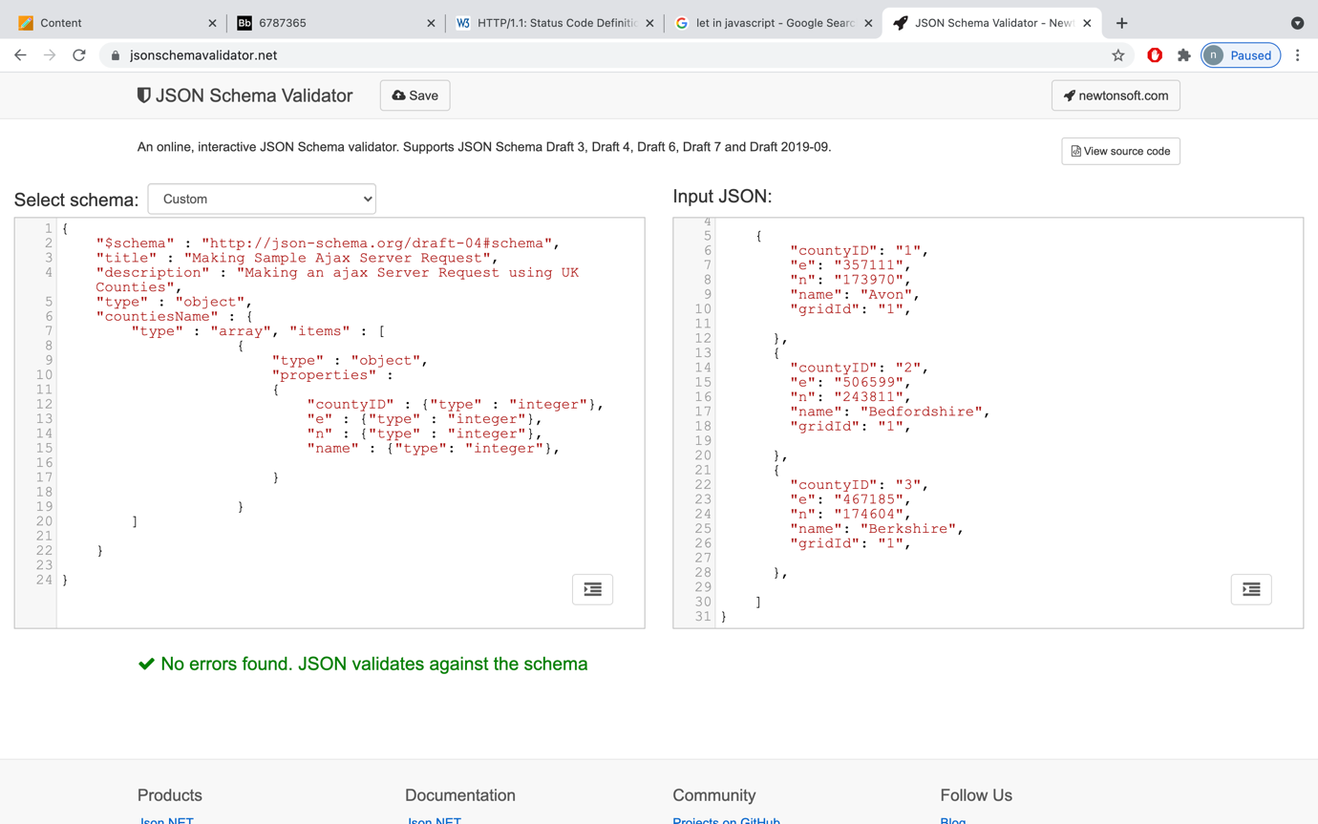

Jquery:

It is a library which uses some javascript methods.

Using jquery we can send json data.

$.ajax() method will take everything and send and get the response from the server.

$.each(function) – To iterate the data

$.find(selector/element) – To find the data

$.append(function)

jQuery provides a range of shorthand methods that cut down much of the work involved in writing Ajax applications (e.g. creating a XMLHttpRequest object, opening it, sending it, etc.).

• The $.ajax() method is the preferred way of creating Ajax requests with jQuery.

• $.ajax() takes a configuration object which contains a set of options required to complete an Ajax request.

url - The location of the data.

type - The type of transaction (GET or POST).

datatype - The type of the data being returned (e.g. XML, JSON).

success - A callback function to run if the Ajax request is successful . This function takes the returned data as a parameter.

error - A callback function to run if the Ajax request is not successful.

url,

type

datatype

success

error

Example:

$.ajax( {

url: “countries.json”,

type: GET,

datatype : “json”,

success: function(response) { },

error: function(error){}

});

Local Web server:

1. Install Nodejs Package
2. Check the version as below:

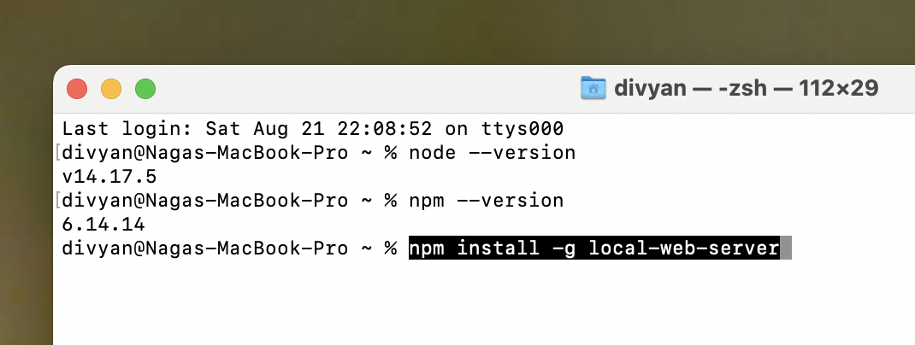

1. Enter the local web server install command:

npm install -g local-web-server

1. 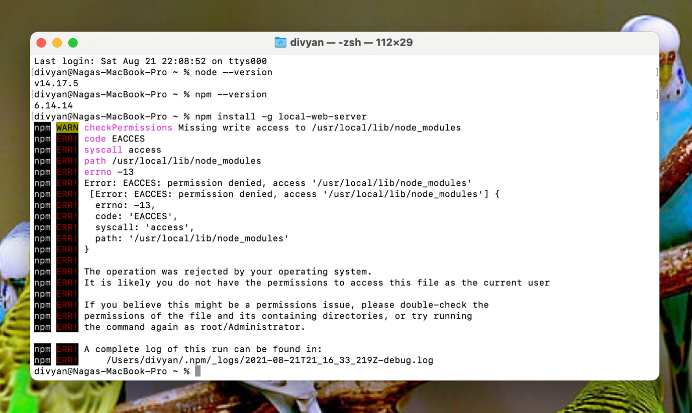
2. 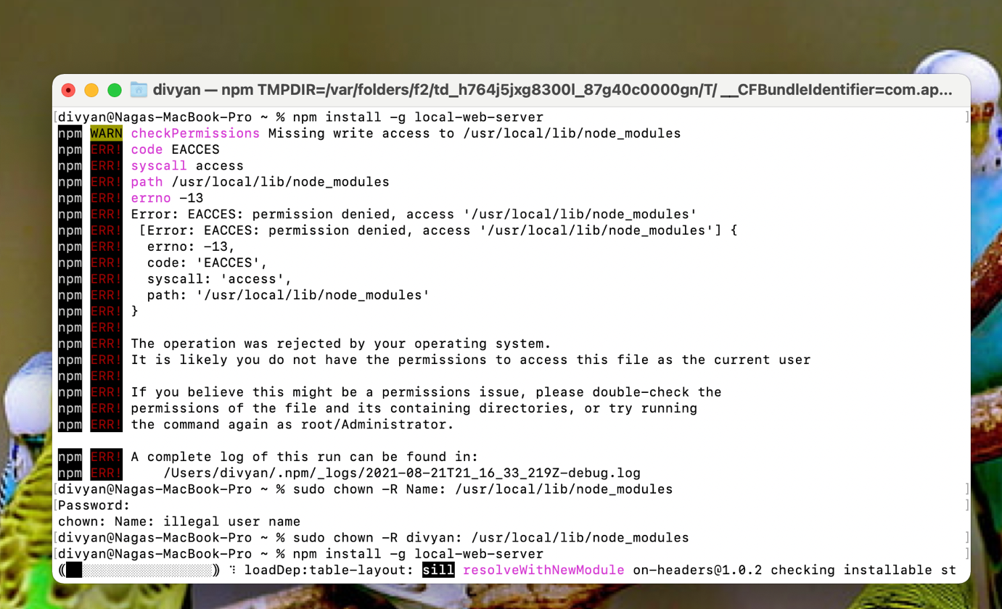

sudo npm install -g local-web-server

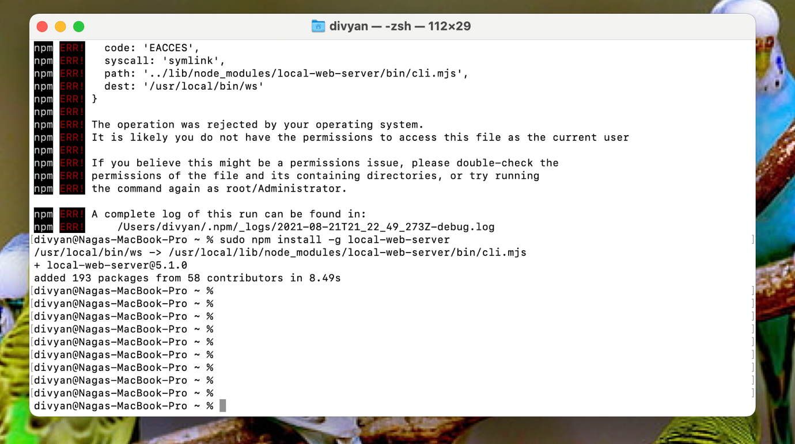

ws --port 2021 --index.root . --spa.asset-test-fs --hostname localhost --open --spa Week8/ajaxJson.html